Nomen:______________________ Date:____________
Ms. Kane-___Period Ch. 14 Vocabulary Practice
Identify the 10 I-Stem nouns from this chapter (include our irregular noun in this count)

Complete the Dictionary Entry:
Nominative | Genitive | Gender | Definition
 |  |  | ear
 |  |  | death
os
 | iuris
 | partis
 |  |  | cloud
 | animalis
 |  | M or F
mare
 | urbis
vis
aqua
 |  |  | Crowd, uproar
 |  |  | Art, skill
Roma

Write what case the following Prepositions take:

A/ab: plus _____case; from, away from

Trans: plus_____case; across

Complete the Dictionary Entry
1st Prin. Part | 2nd Prin. Part | 3rd Prin. Part | 4th Prin. Part | Definition
 |  |  |  | To change, alter
 |  |  |  | To call, name, address, speak to
 |  |  |  | To avoid, shun
 |  |  |  | To run, rush
 |  |  |  | To hold, keep, possess, restrain

Answer the following Questions:

- From which Latin word do we derive jury?
- From which Latin word do we derive orator?
- From which Latin word do we derive partisan?
- From which Latin word do we derive aquarium?
- From which Latin word do we derive mortal?
- From which Latin word do we derive artist?
- From which Latin word do we derive civil?
- From which Latin word do we derive submarine?
- From which Latin word do we derive romance?
- From which Latin word do we derive tenacious?
- From which Latin word do we derive immutable?
- From which Latin word do we derive cursive?
- From which Latin word do we derive appeal?
- From which Latin word do we derive suburb?
- From which Latin word do we derive turbulent?
- From which Latin word do we derive violent?
- From which Latin word do we derive transfer?
- From which Latin word do we derive inevitable?

Complete the Crossword (You will want to do this in pencil)

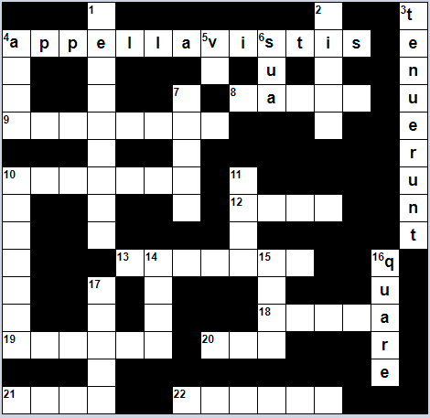

Across |  | Down
4. You (pl) called  8. of the sea  9. of the mobs  10. To the animal  12. By the law  13. Of parts  18. Wars  - To alter  - With the face  - Death  - Of clouds |  | - We will hold  - Citizen  - They restrained  - She loves  - With force  - Her own  - Of the ear  10. Of the waters  11. To the citizen  14. By means of skill  15. With the city  16. Wherefore, why, for what reason  17. across

